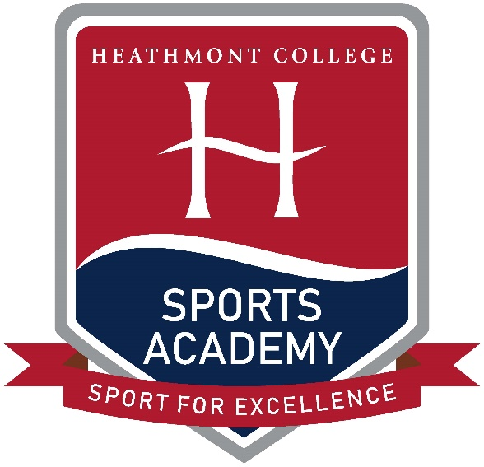
The Heathmont College Sports Academy has been established to enhance students Sporting, Academic and Vocational opportunities through a holistic sporting approach. The academy has a range of key partnerships and programs with numerous sporting bodies and local community facilities to help deliver a relevant and comprehensive program that is tailored for your child’s chosen sport or identified talent.
The aim of Heathmont College Sports Academy is to:
- Offer a student-athlete friendly environment
- Further develop athlete’s knowledge through a holistic sporting approach including curriculum, health and wellbeing, performance analysis, fitness testing, sports psychology and game sense.
- Opportunity to extend their sporting talents via a detailed, supportive and flexible sports academy curriculum that covers enhancement opportunities, match-play, strength and conditioning education, and high-performance training, nutrition and recovery education.
- Professionally accredited coaches that oversee each academy program and facilitate team and individual feedback through the standard academy structure and term-based progress meetings.
- Competition opportunities through school sport, interschool sport and other sporting academies.
- Training opportunities both at school and in the wider community.
- Fully tailored strength and conditioning program for each student that is reviewed as needed.
- Support students in future career planning, development and aspirations through numerous strands including sporting pathways.

Sports Proposed
AFL and AFLW Basketball Netball
Soccer Gifted Athlete Program Striking Sports

Current Proposed Structure for 2021
Monday | Tuesday | Wednesday | Thursday | Friday
Sports Academy  8.30am - 10.05am | Sports Academy  8.30am – 10.05am | No Academy | Sports Academy  8.30am - 10.05am | Sports Academy  8.30am – 10.05am
 | Strength and Conditioning  1.19pm – 2.05pm | *Academy Academic Support  1.19pm – 2.05pm | Strength and Conditioning  1.19pm – 2.05pm

Sports Academy Sessions include:
- Technical Skill development
- Tactical Skill development
- Health and Wellbeing sessions
- Competitions/Inter-academy competitions
- Fitness testing and data analysis
- Peer analysis and assessment
- Training sessions run by elite sporting bodies
- Student-athlete development of coaching practices for leadership opportunities
- Recovery
Ongoing support will be given to the student-athletes to help balance their demanding schedules. This will be arranged through term-based progress meetings and weekly academic support classes that are offered to academy students.
*Weekly academic support classes must be attended by those students who have failed to hand in work on time to a satisfactory standard.
Application Process

- Complete and return the ‘Expression of Interest’ form by May 17th, 2020. For forms or more information please contact Elise Hopkins via email at hopkins.elise.j@edumail.vic.gov.au or by phone on (03) 9871 4888.
- Testing Day: more information will be provided upon submitting an expression of interest form. Please be aware there is a $50 cost.
- Application Review: All applications will be thoroughly reviewed by the Director and Assistant Director of Heathmont College Sports Academy.
- Knowledge of Acceptance: 14th of August 2020 via email.
Note: Upon acceptance into Heathmont Sports Academy, a deposit of $500 is to be paid. Your position will be held for a maximum of 14 days before forfeiting your place in the Academy.
NEED TO KNOW:
Being selected into the Heathmont Sports Academy means you have a position in the academy for that calendar year. You do not automatically get accepted into the program the following year. Student-athletes are required to maintain a minimum behaviour and academic standard, as well as abide by all terms and conditions set out in the ‘Student-Athlete Agreement’ that is signed at the commencement of each year. Students who fail to meet these standards or fail to uphold the ‘Student-Athlete Agreement’ will forfeit their place in the Academy when deemed by the Director of Heathmont Sports Academy and Heathmont College. No refunds will be given to students who forfeit their position in the Academy. A yearly review/application process will be undertaken as to whether your child will receive a place in the Academy for the following year.

Elise Hopkins Lachlan Watson
Academy Director Academy Assistant Director

